

The primary aim of this session was to provide students with an immersive, experiential understanding of the Partition of Bengal in 1905, using a non-traditional learning environment.

**Learning Objective:**

* To explain the causes and consequences of the Partition of Bengal.
* To explore the role of Lord Curzon and the British imperial strategy.
* To highlight the Indian nationalist response, including the Swadeshi Movement.
* To encourage active participation and emotional engagement with historical content through a mobile classroom setup inside the bus.

**Pre preparation for the Activity:**

* A few students were used as volunteers for chart preparation to be displayed inside the Bus.
* Customised tickets were issued to get inside the bus.
* Based on random allocation- roles were assigned for students as Lord Curzon, Nationalist, common people – Hindus and Muslims.
* Considering the heat of summer fans were arranged outside the bus for a comfortable environment inside the bus.
* Speakers and mikes were arranged
* Songs Amar sonar Bangla and ---- was downloaded and kept ready to be played, lyrics of the song was also printed and kept ready to be distributed while the singing activity was to be performed the next day.

**Topic: Partition of Bengal, 1905**

**History on Wheels – A Creative Teaching Methodology**



**Teaching inside the Bus – History on Wheels**

History on Wheels transformed a standard school bus into a dynamic, mobile classroom. The bus interior was decorated to reflect the era of early 20th-century Bengal – using chart presentation and flash cards, posters, newspaper clippings. Audio recording of Amar sonar Bangla and another Bengali song “ekla cholo, ekla chalo, aekla chalo re…” was played inside the bus and rasagulla was served to all students and teachers to give a feeling of being in Bengal.

**Activities Conducted inside the Bus:**

Visual Timeline Installation: Panels on the bus walls displayed a chronological timeline from the British Raj to the 1905 partition and the subsequent Swadeshi Movement.

**Role Play:** Students were assigned roles of key historical figures such as Lord Curzon, Indian Nationalists and common citizens. A short dramatization was performed on board.

**Interactive Map Activity:** A large map of Bengal (pre- and post-partition) was displayed and explained which helped students visually grasp the geographical and communal changes imposed by the British.

**Singing:**

As Tagore wrote this specific poetry Amar sonar Bangla [My beloved Bengal] and “ekla cholo, ekla chalo, aekla chalo re…” was played, song with lyrics were provided to children to sing inside the bus. It was all fun before they could catch up with tune, laughing at each other when they missed the tune. After two are three attempts they were able to sing along.



**Empathising the Partition:** A teacher narrated first-person fictionalized accounts of people affected by the partition, fostering empathy and critical thinking. “How would you feel if your hometown was suddenly divided?” then students were able to realise the impact of the partition. They were able to ask questions like how would they have gone to work if it was in the other side, what could be the shop owners suffering if the partition tampered upon their business? what if close relatives were separated? – These were some of the questions asked by students. Thus the activity made them think and question.

**Learning technique:**

The usual difficulty faced by students while learning is how to learn that particular topic, which was covered through an activity. That was rectified in the session, by providing the learning technique through a mind map. They were asked to learn the topic by five “W” and one “H” question. i. e. What, Which, When Where, Why and How. Students were made to answer out the topic based these lead question and the key points were reinforced.

**Recapitulation through quiz:** A short quiz was conducted at the end based on “WH” – questions. They came out with correct answers.

**Learning Outcome:**

The mobile classroom method led to strong engagement and retention among students. The following outcomes were observed:

* Enhanced Historical Understanding: Students demonstrated a clear grasp of the Partition of Bengal, its political motives, and its socio-cultural impacts.
* Empathy and Perspective-Taking: Role play and storytelling helped students connect emotionally with the past.
* Collaborative Learning: The shared space encouraged discussion, teamwork, and collective interpretation of historical events.
* Creative Thinking: By stepping into history physically and emotionally, students developed creative ways to express and understand complex events.

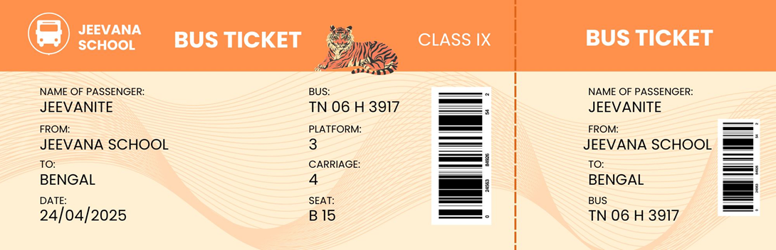

**Bus Tickets Printed and issued:**

For every student who boarded the bus, a specific bus ticket was printed and issued. This a real feeling they were boarding a bus. They occupied seats as per their seat no. Later after Lord Curzon announcing partition, students who were allotted roles as Hindus moved to Bengal proper – the right column of seats and students allotted the role of Muslims went to the left column – East Bengal.

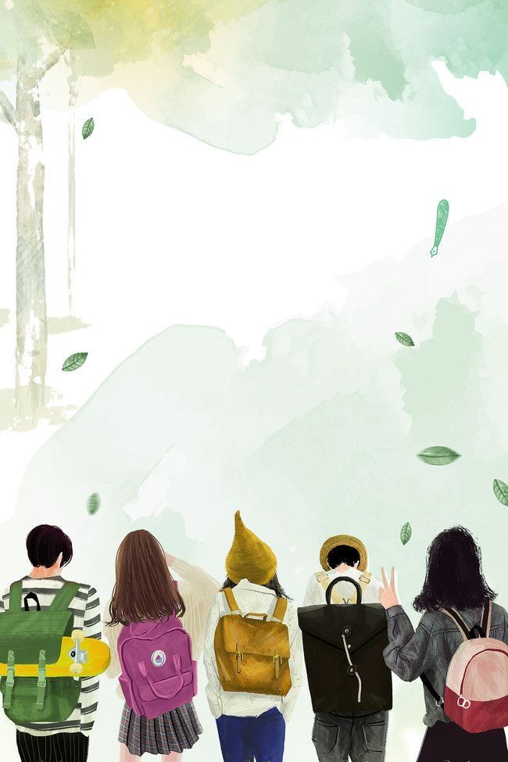

***A***

***Note***

***of Gratitude…***

The class was very interesting and we enjoyed a lot we did not expect such a beautiful class.We all expect more like this and thank you for giving a class like this.

Mahathi – X A

The class was engaging making it easy for us to grasp the concept easily.We came to know more about Partition of Bengal.We felt as if we are travelling to Bengal.The session was both enjoyable and informative.Also we got a deeper understanding about the partition and Lord Curzon's pivotal role.

-M.Karthika - X A



Dear mam,

I am Shivani of class 10 A. The class in the bus was such new experience filled with excitement and fun. It was different a feeling to attend a history class in bus. I wish we have some more of such classes in the future. This was an innovative idea and we are ready to help to execute such new type of classes.

Thank you

Dear Mam I am K. Nilan from 10 mam the history on wheels activity was very fun filled mam we all enjoyed it very much mam especially me and Rishwanth had one mic secretly under the shawl we brought for Hindus and we both made noises we really enjoyed the activity and the rasagula mam thank you mam.



**Feedback from students of X A:**

~ The impressive environment helped us understand the topic in a deeper and more excited way

~ It felt like really visiting to partition of Bengal by time travelling

~ The creative settings made the less and more memorable and enjoyable

~ It was a perfect combination of education and creativity

~ I truly thank you for this experience

* **Kamatchi Darshini**

It brings me to past. It encouraged critical thinking and helped me to connect historical events with real-world consequences. Overall, the activity was informative, interactive, and successfully deepened our understanding of the freedom struggle. ------ **RISHI S P**

Dear Ma'am,

The History on wheels class was very interesting and I was surprised! and thought what ma'am was going to do in the bus? The bus class was clearly understandable than the classroom teaching. The role of the people were explained well by our class mates and it was totally an enjoyable and unforgettable experience.

Thank you,

Yours sincerely,

**Sanjit.**

Dear mam,

The concept of the session was very interactive and I was very happy to be a part of it. Looking forward to more activities Like this and it made me understand the lesson more effectively had fun and enjoyed, tasty roshogulla.

With regards

**YAZHINI Vivek**

