WE CONGRATULATE OUR STUDENTS AND TEACHERS FOR 100% RESULTS
IN ISC, STD XII, 2018


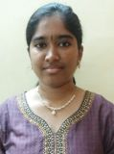

MATHURAVALLI. M
D/o. Mr. M. Muthumari &
Mrs.S. Subacini Devi
474/500
SCHOOL TOPPER
Grade “1” in all Five subjects

KAANAPULI RAMKUMAR. G
S/o. Mrs. P.Chitra Devi
Grade “1” in four outof 5 subjects

* PERCENTAGE OF STUDENTS ABOVE 400 :36% * PERCENTAGE OF STUDENTS SECURING DISTINCTION : 59%

