WE CONGRATULATE OUR STUDENTS AND TEACHERS FOR 100% RESULTS
IN ICSE, STD X, 2018

PROUD TO ANNOUNCE THAT V. HARINI,
D/o. Mr. R. VENKATACHALAPATHY & DR (MRS) UMA RANI, IS THE TOPPER IN THE STATE OF
TAMIL NADU

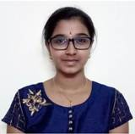

HARINI. V
D/o. Mr. P. P.Venkatachalapathy &
Dr (Mrs) R. Umarani
98.2%
TOPPER IN THE STATE OF TAMIL NADU
Grade “1” in all the six subjects
Centum in Mathematics & Environmental Applications

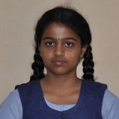
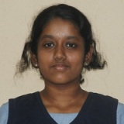
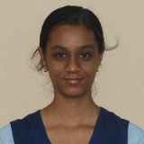
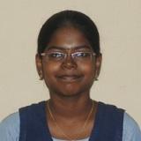

ASMITA MRINAL G
D/o.Dr G. Ganesh Prabhu &
Dr. Mrs. C. Aparna
Grade “1” in five subjects

KEERTHANA SRIJA. R
D/o. Mr.R. Ramesh kumar &
Dr (Mrs)K. Vigneshwari
97.2%
DISTRICT THIRD IN MADURAI
Grade “1” in all the six subjects. Centum in Environmental Applications

DHARINI. N
D/o. Dr.S. Navaneetha Krishnan &
Mrs. C. Maheshwari
Grade “1” in five subjects
Centum in Environmental Applications

SUJITHA. A.V
D/o. Mr. N. Venkatesan &
Mrs. V. Arumugapriya
Grade “1” in all the six subjects



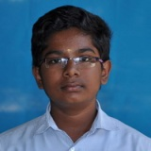
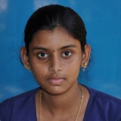
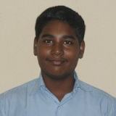

AFRA THASNEEM. M

D/o. Mr.M.A Nazimul Gani. &
Mrs. N. Nabeesa.
Centum in Maths

AKASH. V.B
S/o. Mr. V. Balakumaran &
Mrs. B. Jothilakshmi

Centum in Environmental Applications

VISWA. V
S/o. Mr. P. Venkatesan &
Mrs. K. Murugeswari
Centum in History, Civics & Geography and Mathematics

VINISHAA. I
D/o.Mr. V. Irulappan. &
Mrs. I. Chinnathai @ Suba.
Grade “1” in five subjects

SUSINDHAR. A.V
S/o. Mr. N. Venkatesan &
Mrs. V. Arumugapriya
Grade “1” in five subjects

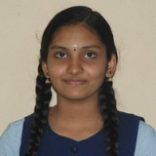
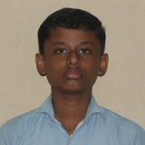
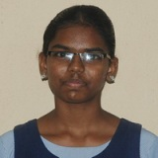
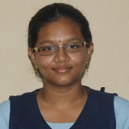

JYOTHSANA SHRI. R
D/o.Mr. K. Ramasubramanian &
Mrs. R. Radhika
Centum in History, Civics & Geography

RAKKSHA. S.B
D/o. Mr. S. Senguttuvan &
Mrs. S. Brinda Devi
Centum in Mathematics

JENA. S

S/o. Mr. S. Shanmuga Sundaram &
Mrs. S. Sathiyavathy
Centum in Mathematics

GLADYS SHERIL. G
D/o. Mr.A. Goldenraja Joseph &
Mrs. T. Glory Selvam.

Centum in History, Civics & Geography

PERCENTAGE OF STUDENTS ABOVE 90% : 21% * PERCENTAGE OF STUDENTS SECURING DISTINCTION : 76%

